Step 1:

Click on manage jenkins

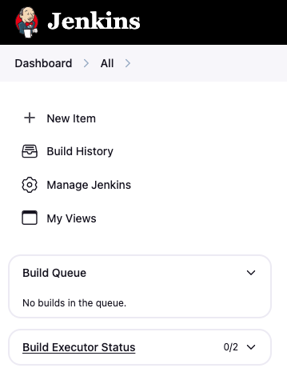

Step 2:

Click on tools section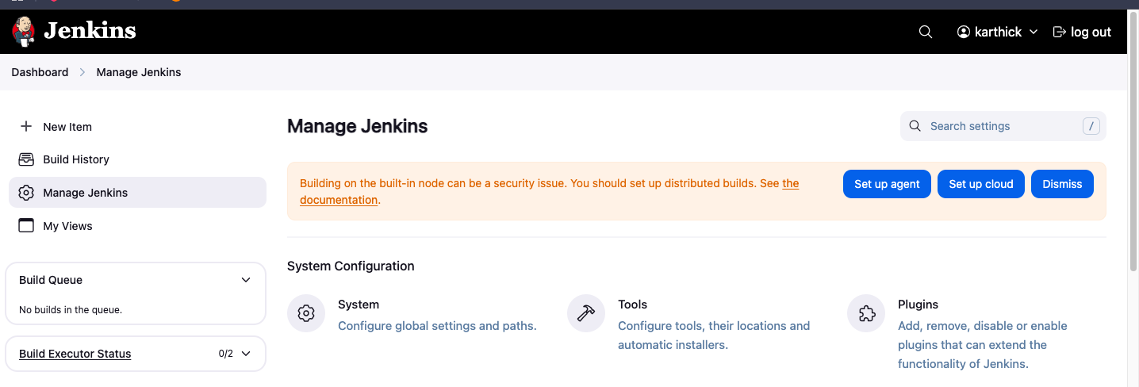

Step 3:

Go to maven installation section

Set maven name and click check box install automatically maven

And chose maven version 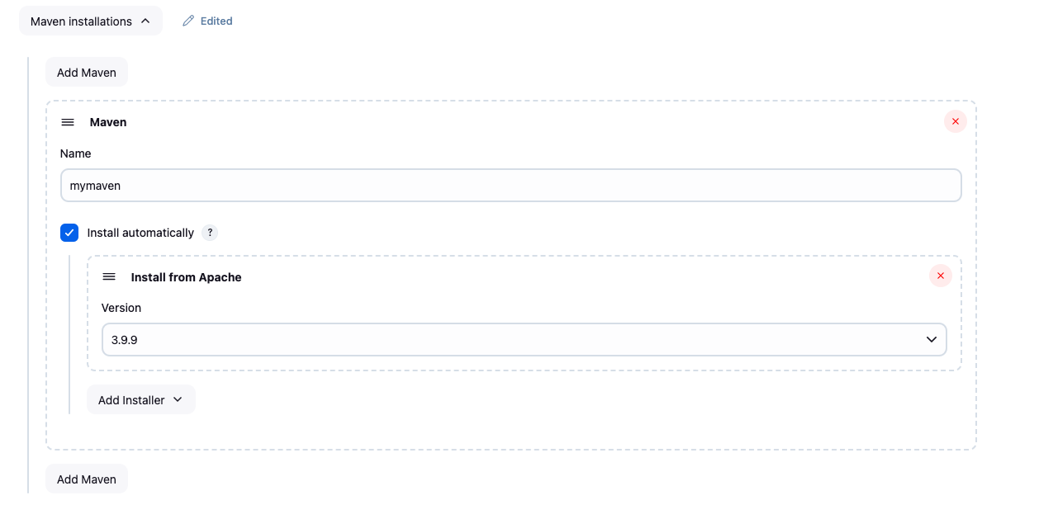

Step 4:

Click on **+** new item

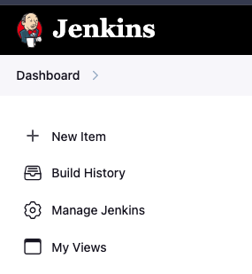

Step 5:

Enter job name and freestyle project and click ok button

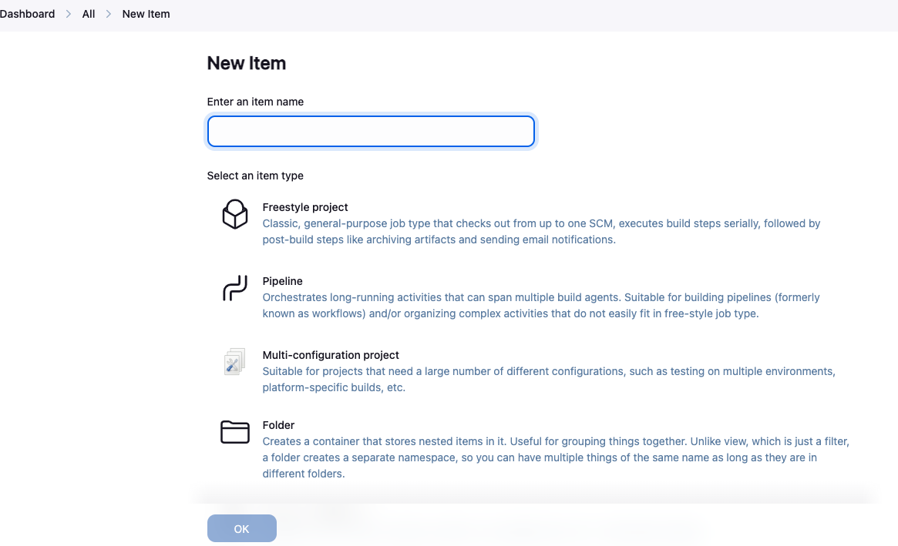

Step 6:

Enter the description of job 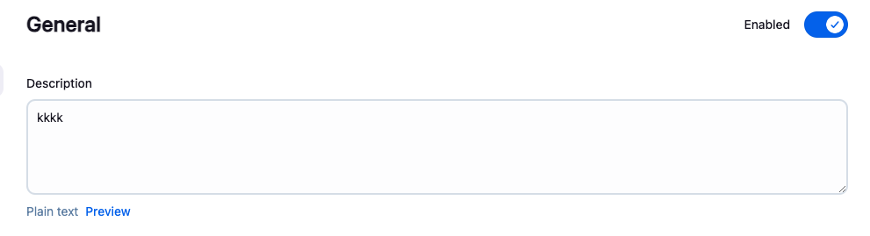

Step7:

Chose git options and give repository URL

repository URL: https://github.com/KarthickSuresh09/jenkins-maven.git

If repository is public means no need to provide credentials

You need to change **Branch Specifier master** to **main**

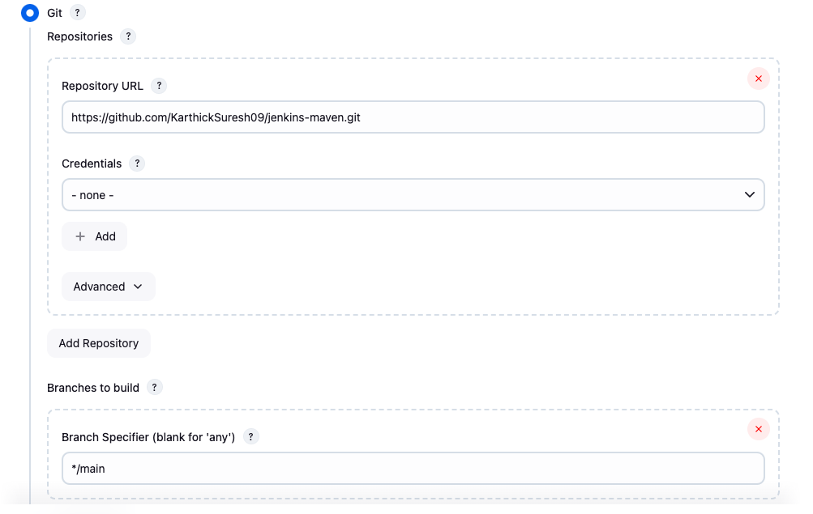

Step 8:

In build step you need to choose **Invoke top-level Maven targets**

Now you need to choose which maven version you chose and maven name in maven

check box

In goals you can give compile

Click on advanced option and you need to mention pom.xml file path

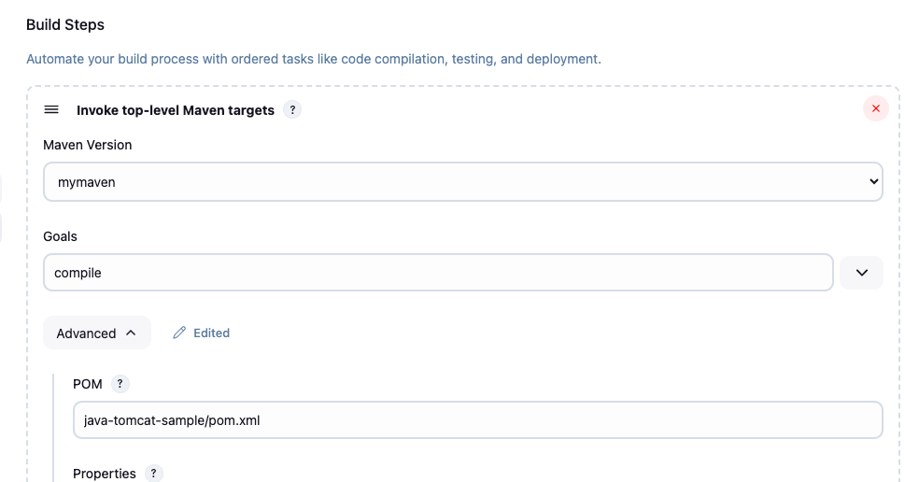

Step 9:

Apply and save the job

Click on build now button and your job will run

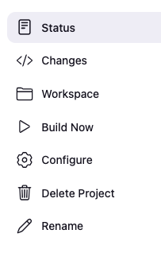

Step 10:

In builds section you get job is succeed or not

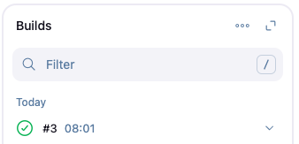

Step 11:

If you clicked job timings and you will enter details and click console output

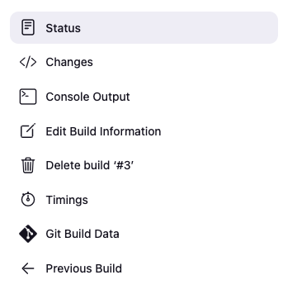

Step 12 :

After clicking console output you will get the logs of the job